Periodic Table and Periodic Trends

Period Table Vocabulary
1. Valence Electrons
a. Electrons in the outermost principal quantum level of an atom
b. Elements in the same group (vertical column) have the same valence electron configuration

2. Transition metals
a. What we have called the "d" block

3. Lanthanide and Actinide Series
a. The sets of 14 elements following lanthanum and actinium
b. What we have called the "f" block

4. Main-group, or Representative Elements
a. Groups 1A through 8A
b. Configurations are consistent

5. Metalloids (semi-metals)
a. Found along the border between metals and nonmetals
b. Exhibit properties of metals and nonmetals

6. Lanthanides and Actinides. These sometimes put an electron in d [just one or two electrons] before filling f.
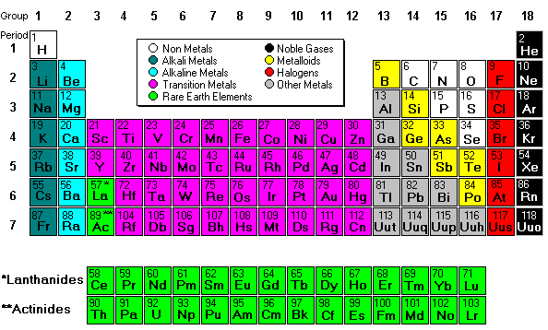

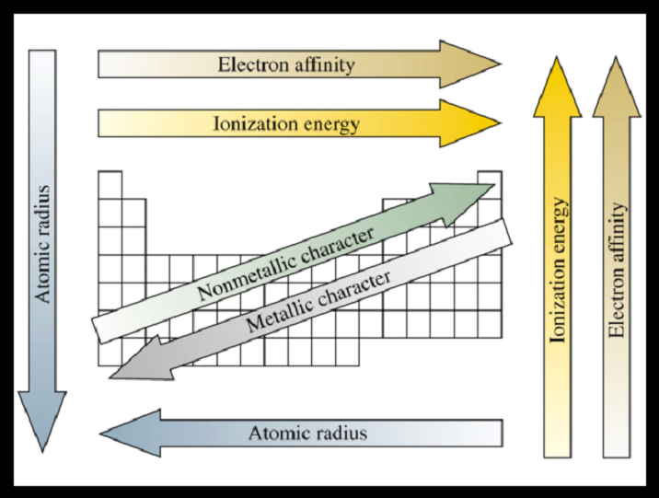

8. Ionization Energy – (Same as Binding Energy)
Minimum energy needed to remove an electron from an atom or ion
  - Gas state
  - Endothermic process
  - Valence electron easiest to remove, lowest IE
  - M(g) + IE₁ → M¹⁺(g) + 1 e–
M⁺¹(g) + IE₂ → M²⁺(g) + 1 e–
1. Ionization energy increases for successive electrons. A high value of ionization energy shows a high attraction between the electron and the nucleus.
The size of that attraction will be governed by:
2. The charge on the nucleus- The more protons there are in the nucleus, the more positively charged the nucleus is, and the more strongly electrons are attracted to it.
3. The distance of the electron from the nucleus-Attraction falls off very rapidly with distance. An electron close to the nucleus will be much more strongly attracted than one further away.
4. The number of electrons between the outer electrons and the nucleus.
Element | First | Second | Third
Na | 496 | 4,560
Mg | 738 | 1,450 | 7,730
The equation for the first ionization energy is:
Na --> Na⁺ + e⁻
The equation for the second ionization energy is:
Na⁺ --> Na²⁺ + e⁻

- First IE decreases down the group.
  - Valence electron farther from nucleus
- First IE generally increases across the period.
  - Effective nuclear charge increases
- First ionization energy generally increases from left to right across a period
- Except from 2A to 3A, 5A to 6A

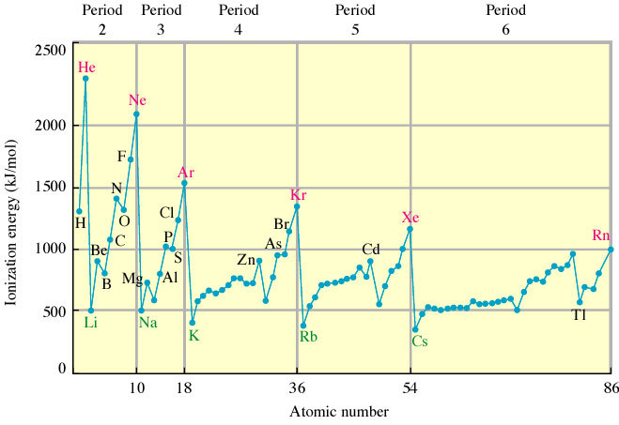

1. Ionization energy increases for successive electrons
2. Ionization energy tends to increase across a period
3. Ionization energy decreases with increasing atomic number within a
group

9. Electron Affinity - Energy is released when an neutral atom gains an electron.
Gas state
M(g) ⁺ 1e− →M¹⁻⁽g) + EA
Electron affinity is defined as exothermic (−), but may actually be endothermic (+).
The more energy that is released, the larger the electron affinity.
The more negative the number, the larger the EA.1. Affinity tends to increase across a period
2. Affinity tends to decrease as you go down in a period
a. electrons farther from the nucleus experience less nuclear attraction
b. Some irregularities due to repulsive forces in the relatively small p orbitals

10. Atomic Radius-. Determination of radius-a. half of the distance between radii in a covalently bonded
1. Periodic Trends
a. Radius decreases across a period
(1) increased effective nuclear charge. Valence electrons are drawn closer to the
nucleus.
b. Radius increases down a group
(1) addition of principal quantum levels(shells)
Valence shell held closer
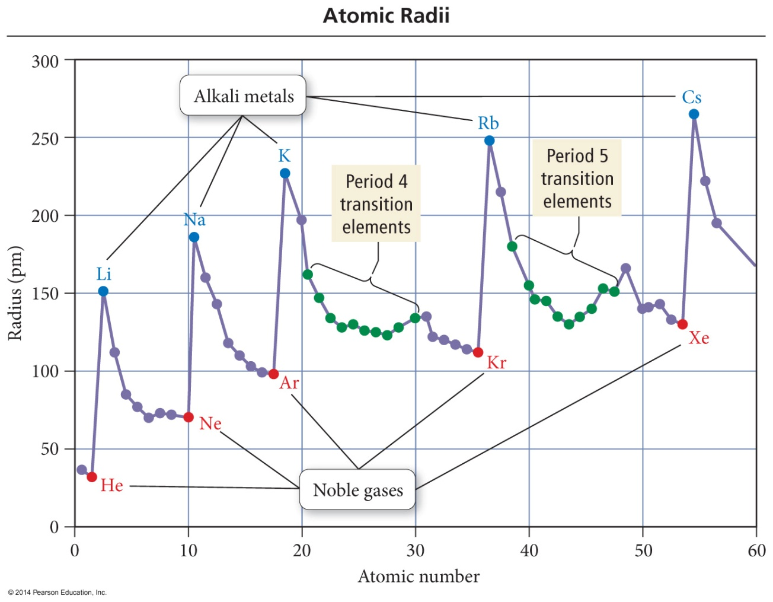

11. Ionic Radii – radium when an ion is formed ( you remember gained or lost an electron)
1. Cations—shrink since the positive charge exceeds the negative charge.
2. Anions—expand since the nucleus is now attracting MORE electrons than there are protons AND there is enhanced electron/electron repulsion
3. Isoelectronic—ions containing the same number of electrons. Example Na+ is
isoelectric with Ne.

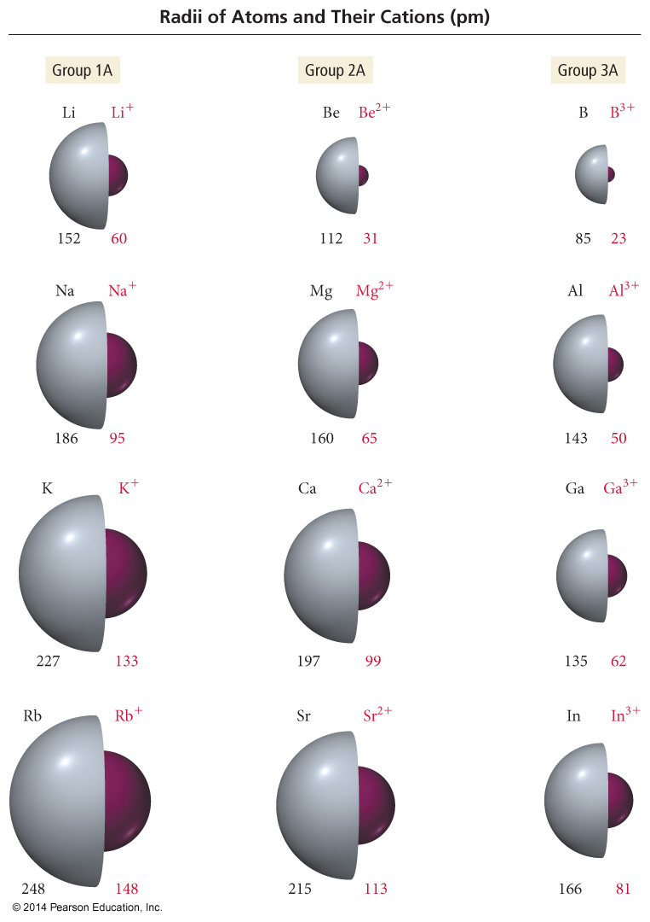
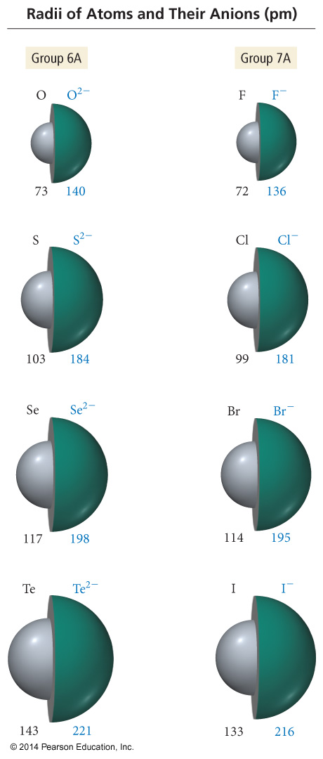
S²⁻ and Ar are isoelectronic. Which would have the largest radius?

Ion | Ionic Radius
Zn²⁺
Ca²⁺
Ba²⁺

Based on the data in the table above, which of the following correctly predicts the relative strength of the attraction of Zn^{2+,} Ca²⁺ and Ba²⁺ ions to water molecules in a solution, from strongest to weakest, and provides the correct reason?
A) Zn²⁺>Ca²⁺>Ba²⁺ because the smaller ions have a stronger coulombic attraction to water.
B) Zn²⁺>Ca²⁺>Ba²⁺ because the smaller ions are more electronegative.
C) Ba²⁺>Ca²⁺>Zn²⁺ because the larger ions are more polarizable.
D) Ba²⁺>Ca²⁺>Zn²⁺ because the larger ions are less electronegative

12. Electronegativity (En)—The ability of an atom IN A MOLECULE to attract electrons to itself.
Fluorine is the most En and Francium is the least En
Why is F the most? Highest Z_{eff} and smallest so that the nucleus is closest to the electrons.
Why is Fr the least? Lowest Z_{eff} and largest so that the nucleus is farthest from the electrons.
Exercise 8 Trends in Ionization Energies
The first ionization energy for phosphorus is 1060 kJ/mol, and that for sulfur is 1005 kJ/mol. Why?

Exercise 9 Ionization Energies
Consider atoms with the following electron configurations:
a. 1s²2s²2p⁶
b. 1s²2s²2p⁶3s¹
c. 1s²2s²2p⁶3s²
Identify each atom. Which atom has the largest first ionization energy, and which one has the smallest second ionization energy? Explain your choices.
A: Ne; largest IE
B: Na
C: Mg; smallest IE₂

Exercise 10 Trends in Radii

Predict the trend in radius for the following ions: Be²⁺, Mg²⁺, Ca²⁺, and Sr²⁺.

Be²⁺ < Mg²⁺ < Ca²⁺ < Sr²⁺

